AR House Decoration

Shubham Kumar Jain (20MCA1073)

Vellore Institute of Technology, Chennai

*Abstract****:*—** **In the real world scenarios building houses and decorating them can be tricky and not knowing what the customer wants may lead to unsatisfied customer or even loss of money but with the help of the new technology Augmented Reality (AR) we can see beforehand how the things may look in the real world before putting them there, We can alter the reality in the world of our smartphones and computers. Using this technology we can create an alternate 3D world with real-time interaction with it.**

*Keywords*— **Image Processing, Augmented Reality, Home Decoration , Unity AR tool Kit**

1. **INTRODUCTION**

Over the most recent couple of years, striking advancement has been made with versatile buyer gadgets. Present day cell phones and tablet PCs offer multi-center processors and designs handling units, which open up new application prospects, for example, increased reality, augmented reality, and 3D recreation. Augmented Reality (AR) is a key innovation that will encourage a change in outlook in the manner in which clients interface with information and has just barely as of late been perceived as a suitable answer for explaining numerous basic needs[2]. The AR innovation can be utilized to imagine information from many sensors all the while overlaying pertinent and significant data over situations through a headset. Cell phones make AR innovation effectively open in the field. With simpler and more available use, a wide range of uses (other than video gaming) become more doable [1] [2]. In rundown, AR is a forthcoming innovation which will majorly affect numerous applications. At present, directing AR is tedious on cell phones. This exceptional issue is intended to address the execution or constant parts of AR. The parts in an AR framework incorporate shading consistency, include following, group alteration, camera (self-)adjustment, sound system coordinating, and multi-see sound system. Additionally, the significant level applications dependent on increased reality, for example smart city, reproduction, and mechanical designing, would require extra computational occasions.[1-2]

Image Processing is a method to play out certain system on an Image, in order to get a redesigned Image or to eliminate some significant information from it. It is a sort of sign getting ready in which information is an Image and yield may be Image or function related with that Image. There are two sorts of techniques used for image processing explicitly, basic and advanced image processing.[4] Analog image processing can be used for the printed duplicates like printouts and photographs. Image specialists use various nuts and bolts of interpretation while using these visual methods. Computerized image processing strategies help in charge of the advanced images by using PCs. The three general stages that a wide scope of data need to experience while using computerized method are pre-processing, improvement, and show, information extraction.]-[1].

In electrical engineering and software engineering, Analog image processing is any image processing task led on two-dimensional Images (instead of digital image processing). if the pictorial portrayal of the data spoke to in analog wave arranges that can be named as simple image. E.g.: TV broadcasting in more established days. through the dish radio wire frameworks. Where as the digital portrayal or storing the data in digital structure is named as a digital image processing E.g. : image data stored in digital logic gates.[3]

This research covers checked on articles from technological conventions [1]. Japan uncovered that their commitment in Image detection was to check certain focuses on a Image and recover information about it through accentuation on the histogram of the model and the pixel sizes. Different examinations [2] included video skims that were integrated with sound skims to concoct shots or images as edges .Detection by algorithm [3] are additionally shown. See below figure1 below.

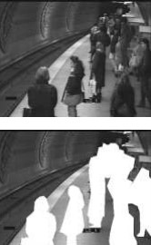

Figure 1: Intensity changes using real-time

images from a subway

Google has thought of a way to handle Image finding. It has presented Google lens., visual acknowledgment programming for Android that includes a notetaking highlight helping clients to have a pursuit history of Images they had recently taken. The application is still genuinely restricted in its extent of its acknowledgment capacities. Presently it can as it were perceive basic Images or articles that are as of now put away on the web. It depends on labels when Lens can't locate a comparative image. Figure 2 represents this.

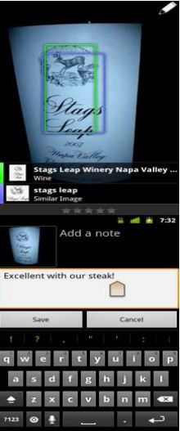

Figure 2: Clint Boulton, writer for a WEEK. Google

Lenses 1.4 visual recognition software for Android

Computer Vision is the field which has techniques for securing, preparing and examining the digital images. These undertakings are utilized in Augmented Reality. Expanded The truth is an innovation which superimposes a computer produced image on the client's perspective on this present reality. This composites the genuine and virtual world in gadget's space. It is the arrangement of technologies that that superimposes the digital information to physical world. Computer vision calculations have wide applications today. These days, AR is the most sweltering point for conversation. Augmented Reality innovation was first presented in 1968. This was imagined by a Harvard educator and his understudy. The primary advancement in this innovation was highlighted with head mounted display.

[2-4].

1. Introduction to AR

Augmented Reality (AR) is another advancement that incorporates the overlay of PC structures on this current reality (Figure 3). One of the best reviews of the innovation is [5], that characterized the field, depicted numerous issues, what's more, summed up the improvements up to that point. That paper gives a beginning stage for anybody keen on investigating or utilizing Augmented Reality. AR is inside a more broad setting named Blended Reality (MR) [6], which alludes to a multi-hub range of regions that spread Augmented Reality (VR), AR, telepresence, and other related advances. Augmented Reality is a term used for computer created 3D circumstances that license the customer to enter and associate with built circumstances [7][10][12]. The customers can "lower" themselves to varying degrees in the PCs counterfeit world which may either be an entertainment of some kind of reality [8] or the reenactment of an unusual marvel [7][9].

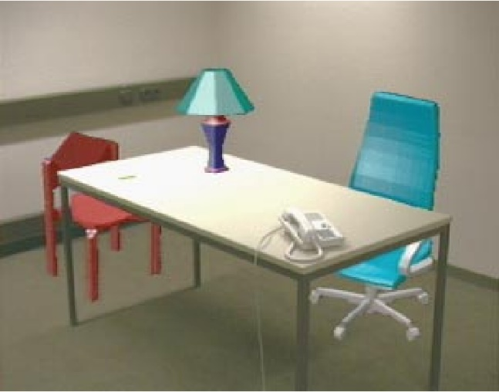

Figure 3 : AR example with virtual

chairs and a virtual lamp

1. Features of AR

Augmented reality is the upgrade of the perspective on the real world with CG overlays, for example, illustrations, text, recordings or sounds, and over all AR applications, object recognition is particularly extreme.[7] The greater part of these apps are marker-rich, which implies they utilize extraordinary images, pictures, or objects to trigger pre-characterized 3D perception, movement, video, or soundtrack. As it were, they use object detection and tracking to figure out what significant data ought to be added to the real world.[10][9][6]

1. Application of Augmented reality

Augmented reality is the mixing of insightful progressed parts – like surprising visual overlays, buzzy haptic examination, or other material projections – into our genuine natural variables. In the event that you encountered the aggravation of Pokemon. See Figure(4) Go, you saw augmented reality, in fact. This (when inconceivably prominent) flexible game permitted customers to see their general natural elements through their telephone cameras while imagining game things, including onscreen pictures, score, and ever-subtle Pokemon animals, as overlays that caused them to appear as though those things were direct in your genuine neighborhood. The system was striking to the point that it sent an enormous number of children and grown-ups the proportionate strolling (and absentmindedly swaying) through their genuine yards looking for virtual prizes.[11]



Figure 4 : Pokemon 3D modal in augmented reality

II.OBJECTIVES OF THE WORK

In the real world scenarios building houses and decorating them can be tricky and not knowing what the customer wants may lead to unsatisfied customer or even loss of money but with the help of the new technology Augmented Reality (AR) we can see beforehand how the things may look in the real world before putting them there, We can alter the reality in the world of our smartphones and computers. Using this technology we can create an alternate 3D world with real-time interaction with it. Using the AR we can create 3D modal copy for a seen and make changes in seen and can seen in the real time and life like real experiences thorough the device using the AR technology . It’s like changes made in the 3D model a actually in the real world there are many application for this technology , But the one we are focusing on is house decoration. replacing certain area of seen with some other content is a part of augmented reality as it can change the color of a wall in 3D modal of the seen. and its showing different different color as we like to choose our wall. And its sence a like printed in real world . we can create 3D modal for couches , bed and even humans and it can put them in 3D modal and you can choose around modals of the beds, color of the beds, pattern of the beds, size of the beds, etc. its really good app to utilize space in the room. User can checkout an entire house just by the use of cell phone or mobile phone camera application integrated with augmented reality technology and you can experience like real house by walking inside in a real life experience in any house of location and augmented reality provides unique technique to chance visit the desired property without travelling anywhere. It developed as a real estate solution and it allows property owners to demonstrate clients to all over the world. With the help augmented reality we can choose home decor like furniture. if we want buy a new furniture and we still in confused which furniture is best for our house as well as house decoration at the time of choosing we can use augmented reality then we can see in application of augmented reality then choose easily for house decoration.

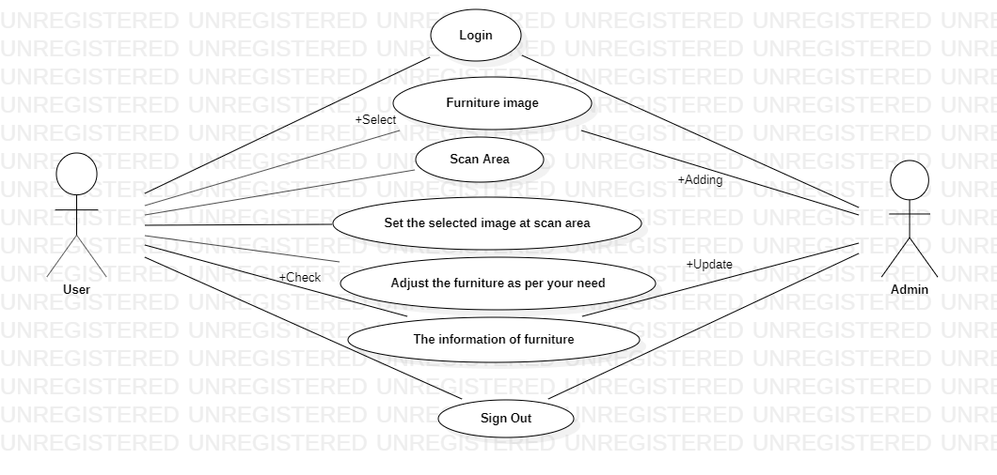

Figure 5 : Use case Diagram

III. DESCRIPTION

1)In the AR project initial it start from the login screen in that screen existing user can login our account and new user can create a account to access the application features.

2)In the next section users can select the furniture image from the catalogue they can access the image in alphabetical order and systematics order so they can choose the image without difficulty and effort. In the catalogue owner can update the new images for the users.

3)Then the user have a option to select the area where they want to add image with the help of smart phone camera the camera can detect the surface area to adding image and the image automatic will come in surface area it will display in user camera.

4)Then the user can set the furniture image at selected area they can adjust the image where they want to add image for the better view of image in 3D model.

5)Then user can take decision to finalize the product in these case user is not satisfied with the image they have selected so they have a option to select another then the user can follow the step [2 to 4].

6)If the user is satisfied by the image selected by their own so they can buy the product from store.

7)The user can sign out of the application by clicking the sign out button in the menu.

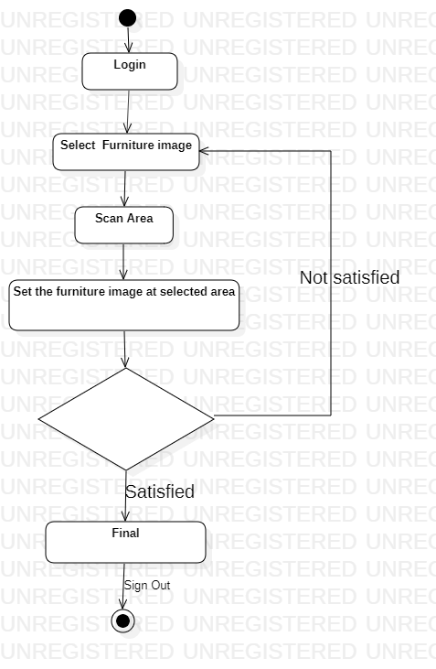

Figure 6 : Activity Diagram

IV. RESULT

Based on my methodology, I developed an android application which is used for home decoration; it means if you would like to check that which interior décor suits your home.

No need to imagine, check it out virtually with my application. I used android studio for developing this project. A snapshot of this application shown in Figure 7, Figure 8, Figure 9, Figure 10.

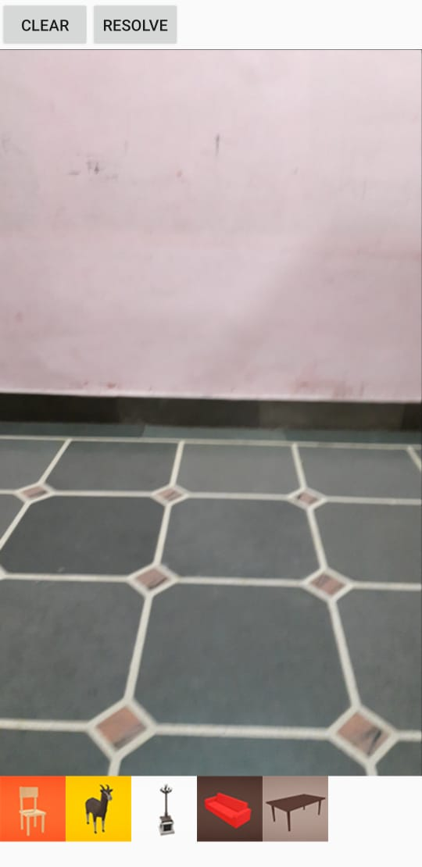

Figure 7: Open application

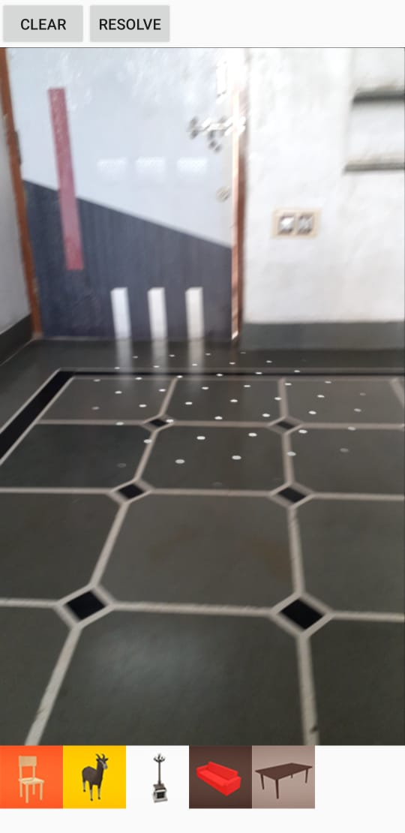

Figure 8: Scanning Surface

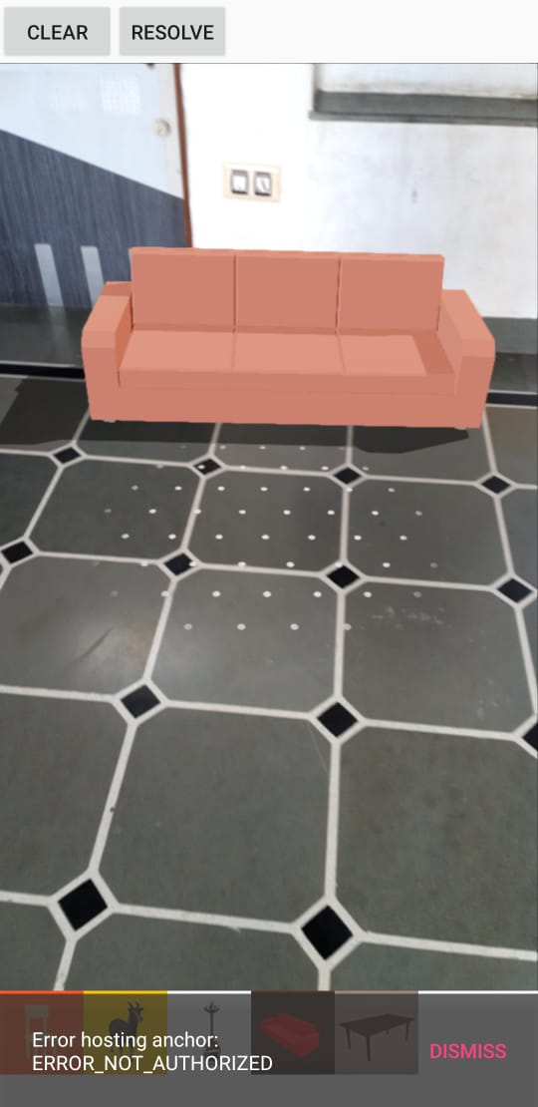

Figure 9: Putting the image on white dots

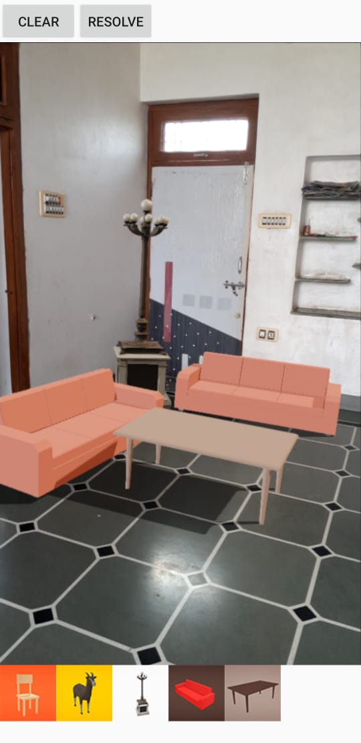

Figure 10: As a result, it will be seen like the above picture.

V. CONCLUSIONS AND FUTURE WORK

Overall, this is a project through which people can easily checkout and arrange their home décor according to their wish list. They would also be able to judge the different varieties of decoration materials.

I have left some space also in this application so that anymore ideas could be implemented in the future. Likewise, any sofa design or can be added to the online shopping sites.

REFERENCES

1. <https://sisu.ut.ee/imageprocessing/book/1>
2. Houbing Song ,Zhihan Lv,Jaime Lloret, **“**Journal of Real-Time Image Processing”
3. https://en.wikipedia.org/wiki/Analog_image_processing
4. YueqiangZhang, Langming Zhou, Haibo Liu, and Yang Shang, “A Flexible Online Camera Calibration Using Line Segments”, 1-16, Hindawi Publishing Corporation Journal of Sensors Volume2016
5. R. Azuma. A survey of augmented reality. ACM SIGGRAPH, 1-38, 1997.
6. P. Milgram and F. Kishino. A taxonomy of mixed reality visual displays. IEICE Transactions on Information Systems, E77-D (12): 1321-1329, 1994.
7. A. Van Dam, A. Forsberg, D. Laidlaw, J. LaViola, and R. Simpson. Immersive VR for scientific visualization: A progress report. IEEE Computer Graphics and Applications, 20(6): 26- 52, 2000.
8. P. du Pont. Building complex virtual worlds without programming. EUROGRAPHICS’95 State Of The Art Reports, 61–70, 1995.
9. D. Weimer. Frontiers of Scientific Visualization, chapter 9, ”Brave New Virtual Worlds”., pages 245–278. John Wiley and Sons, Inc., 1994.
10. W. Sherman and A. Craig. Understanding Virtual Reality: *Interface, Applications and Design*. Morgan Kaufmann Publishers, 2003
11. <https://pokemongolive.com/en/>
12. R. Silva and G. Giraldi. Introduction to virtual reality. Technical Report: 06/2003, LNCC, Brazil, 2003.